# Conceptual overview

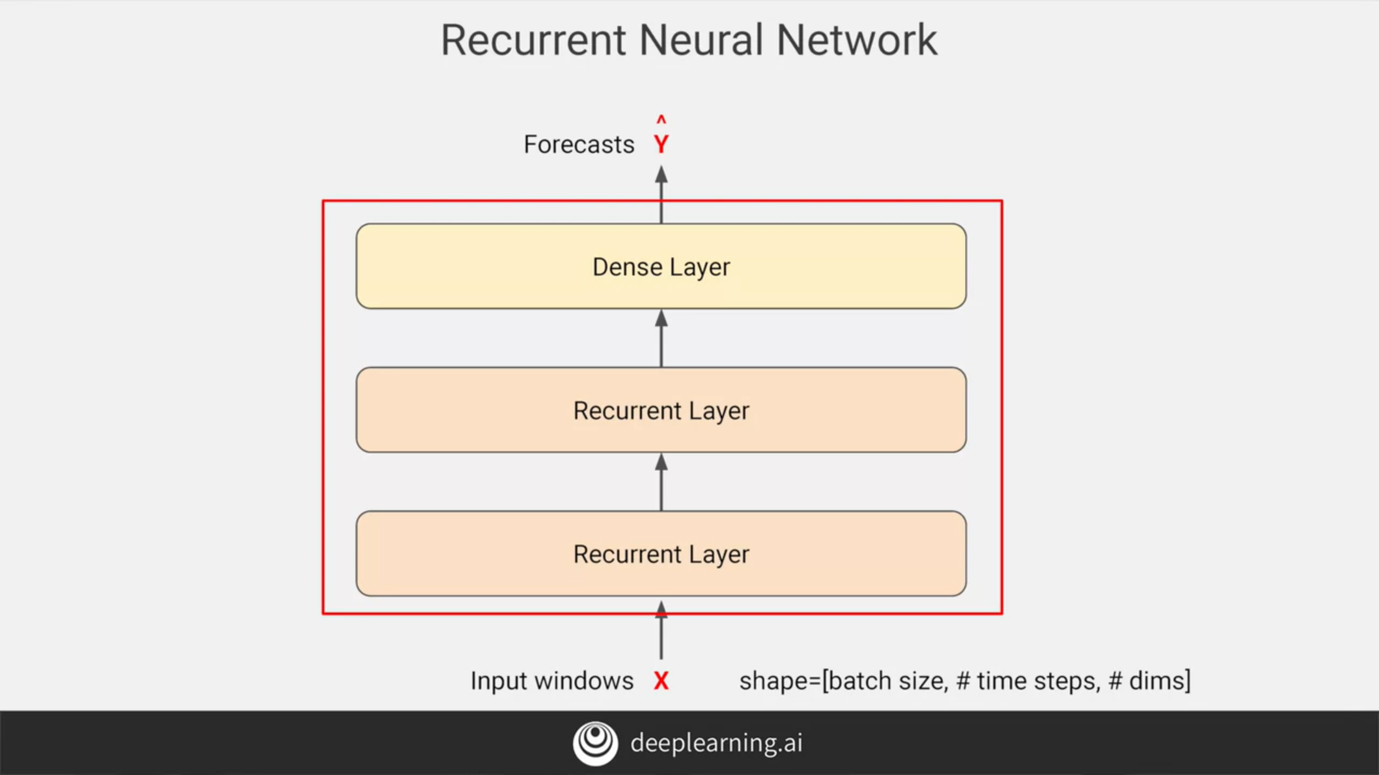

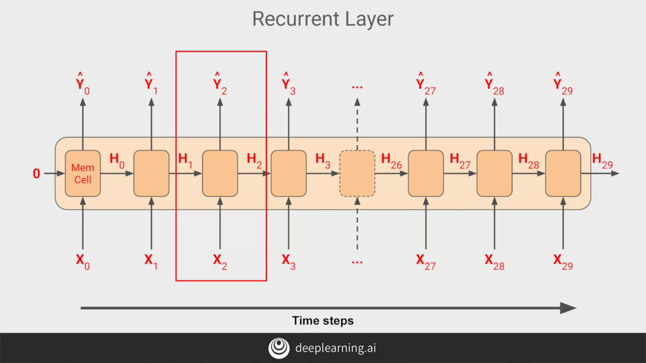

# Shape of the inputs to the RNN

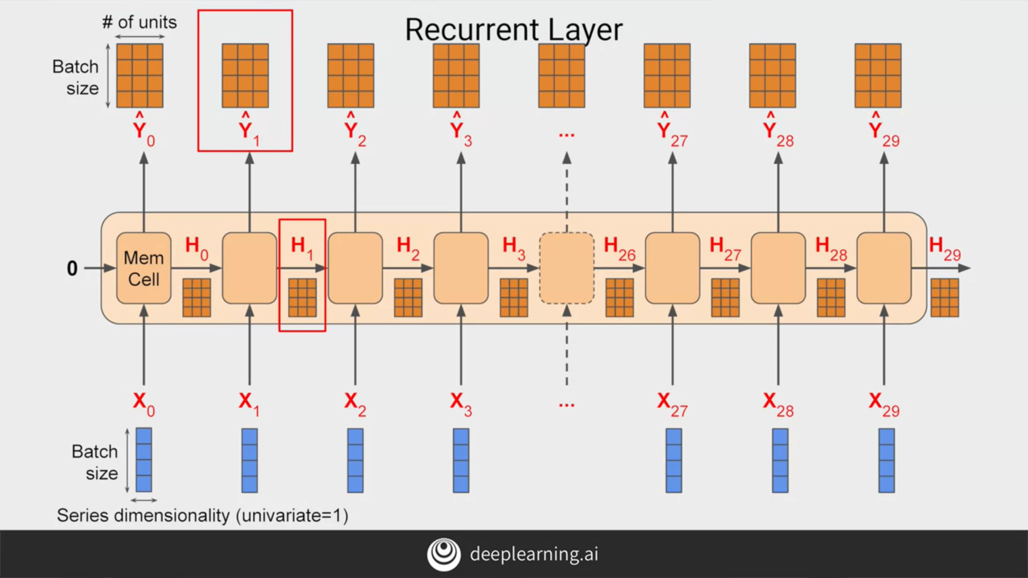

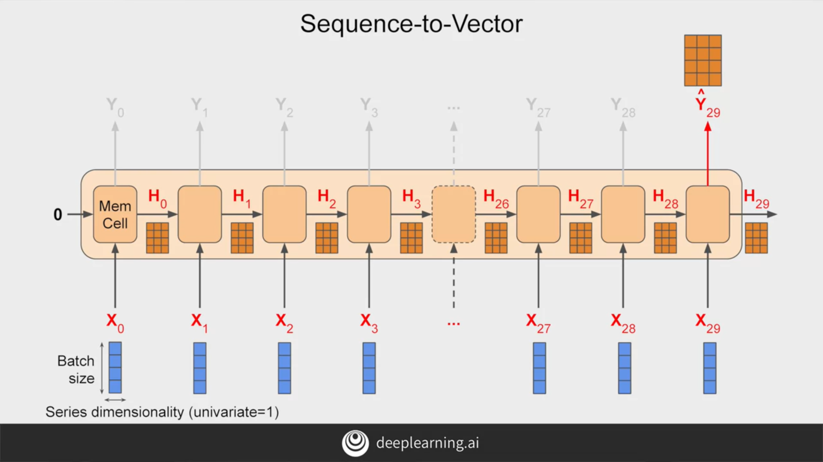

# Outputting a sequence

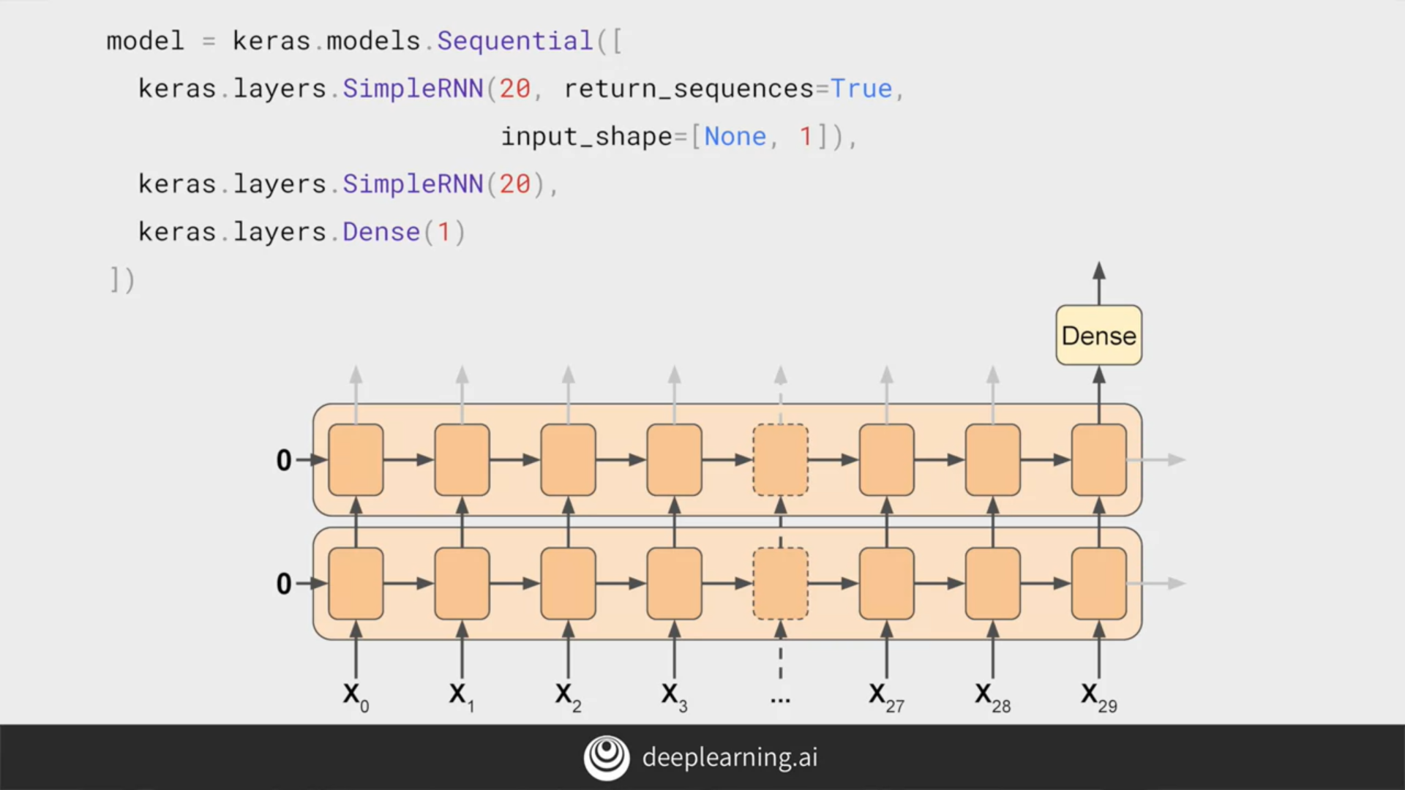

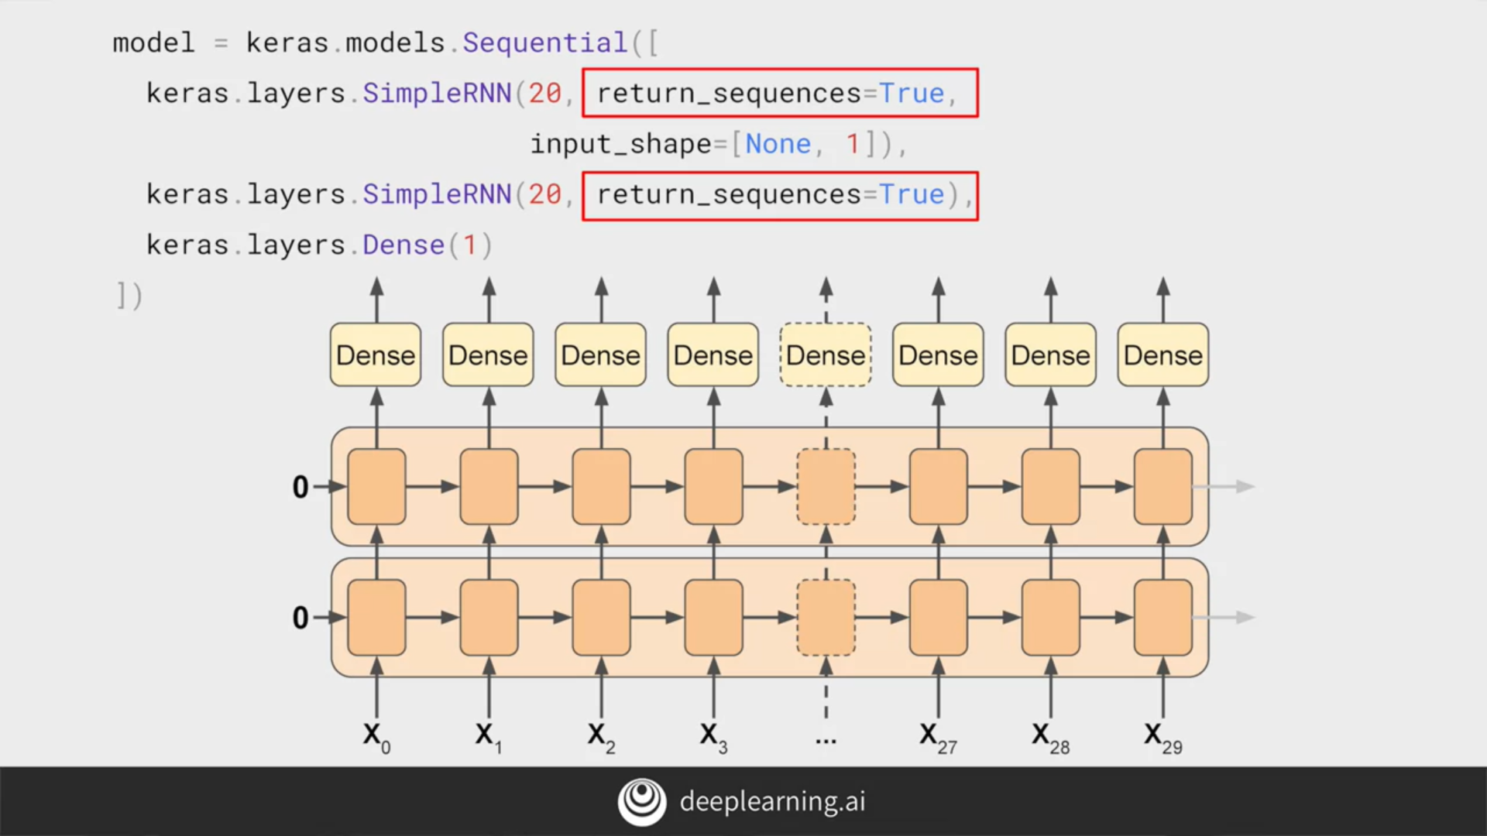

# Lambda layers

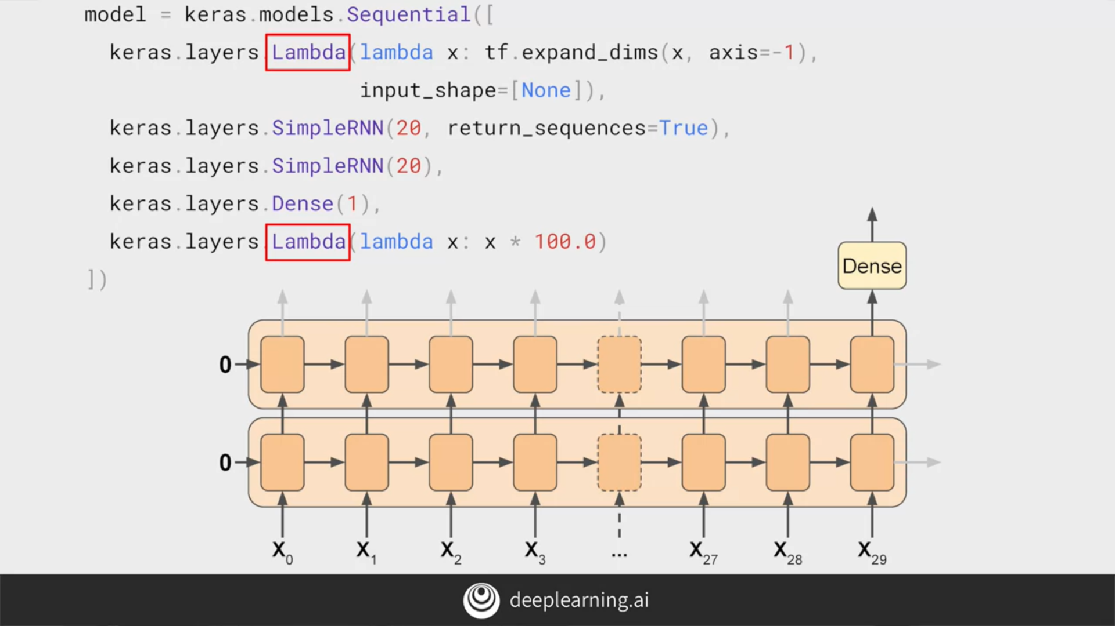

.

If you recall when we wrote

the window dataset helper function,

it returned two-dimensional batches

of Windows on the data,

with the first being the batch size

and the second the number of timestamps.

But an RNN expects three-dimensions;

batch size, the number of timestamps,

and the series dimensionality.

With the Lambda layer,

we can fix this without

rewriting our Window dataset helper function.

Using the Lambda, we just

expand the array by one dimension.

By setting input shape to none,

we're saying that the model can take

sequences of any length.

Similarly, if we scale up the outputs by 100,

we can help training.

The default activation function in

the RNN layers is tan H

which is the hyperbolic tangent activation.

This outputs values between negative one and one.

Since the time series values are in

that order usually in the 10s like 40s, 50s,

60s, and 70s, then scaling up

the outputs to the same ballpark

can help us with learning.

# Adjusting the learning rate dynamically

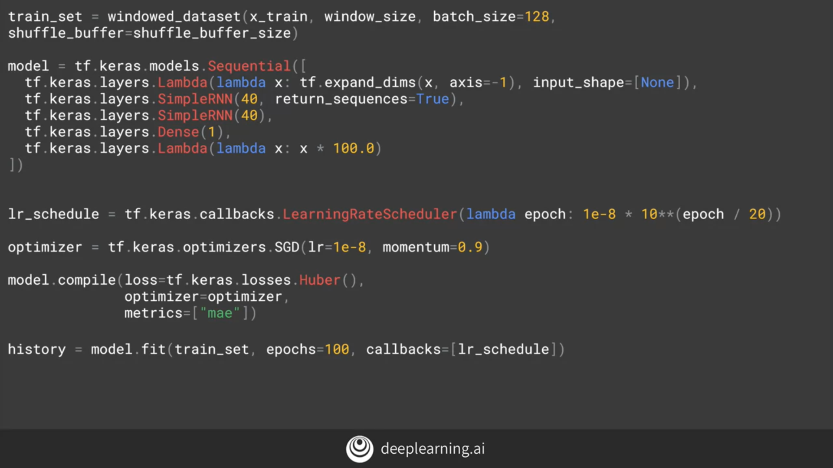

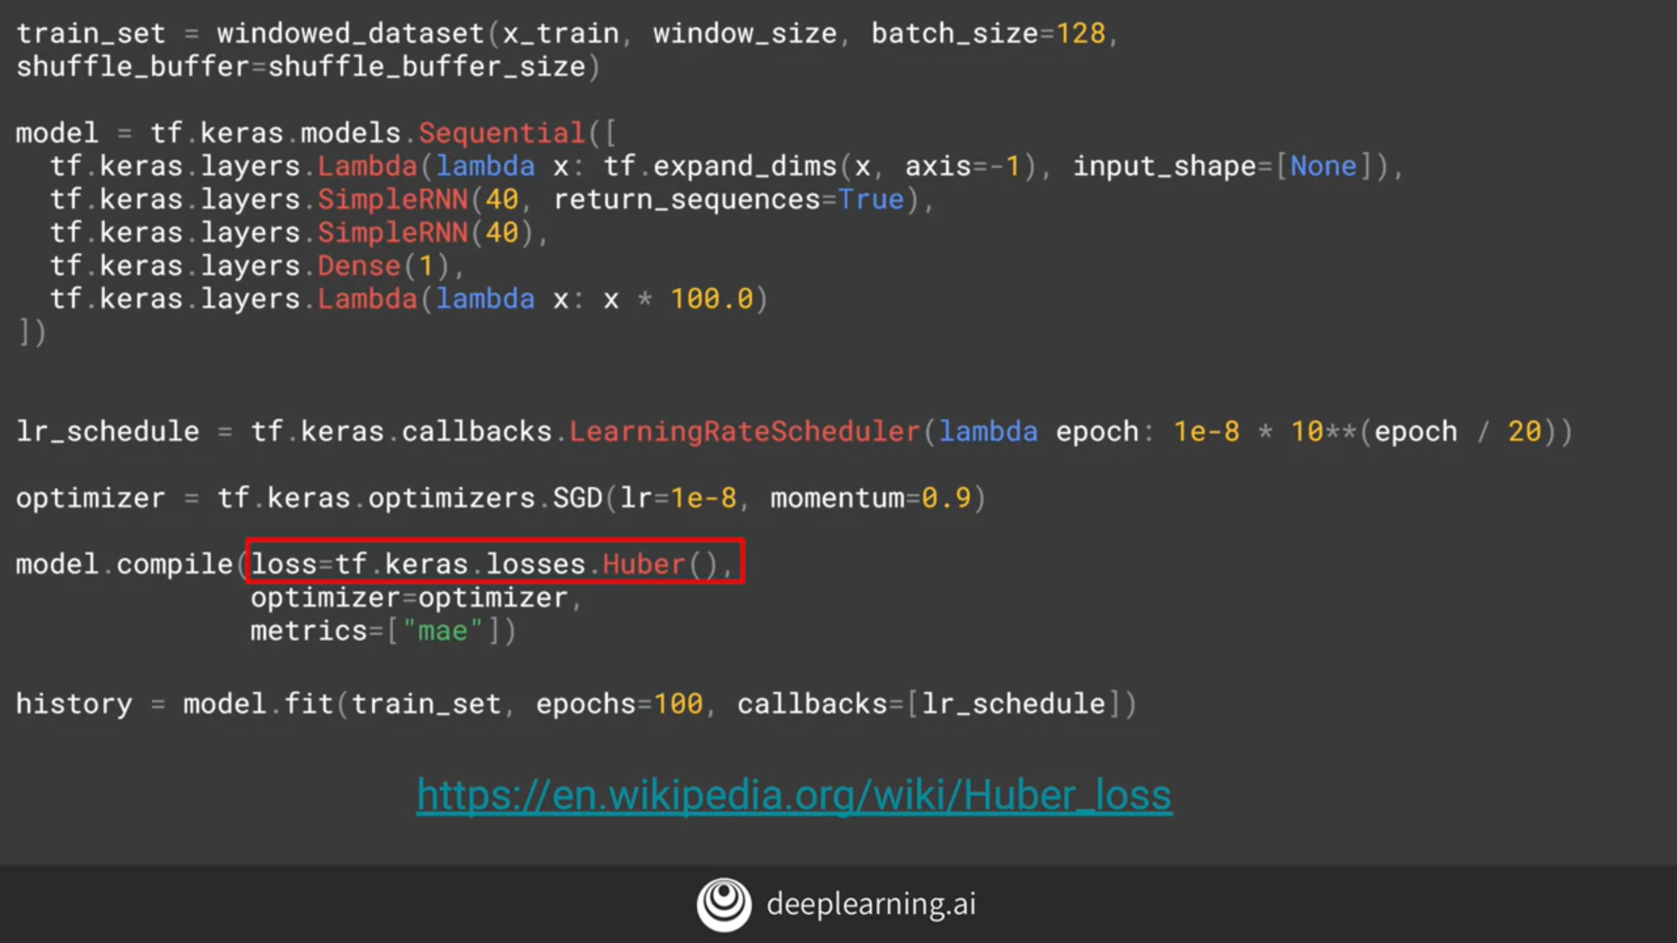

In [statistics](https://en.wikipedia.org/wiki/Statistics), the **Huber loss** is a [loss function](https://en.wikipedia.org/wiki/Loss_function) used in [robust regression](https://en.wikipedia.org/wiki/Robust_regression), that is less sensitive to [outliers](https://en.wikipedia.org/wiki/Outlier) in data than the [squared error loss](https://en.wikipedia.org/wiki/Squared_error_loss). A variant for classification is also sometimes used.

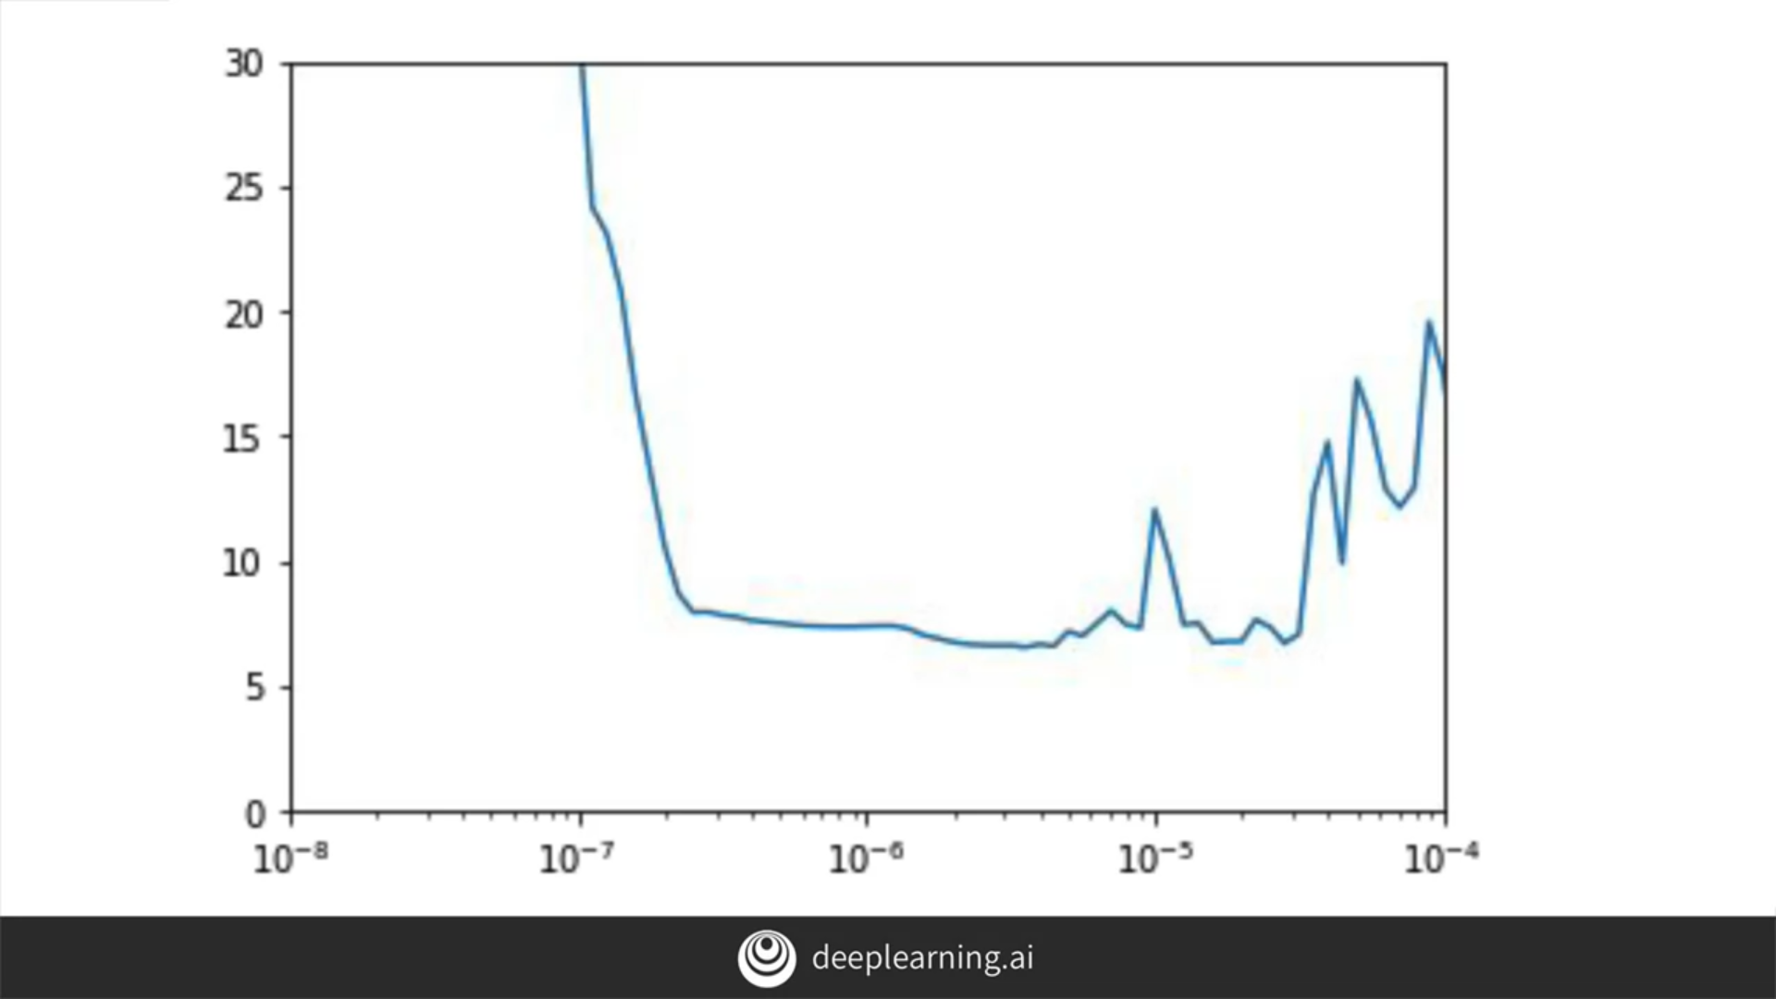

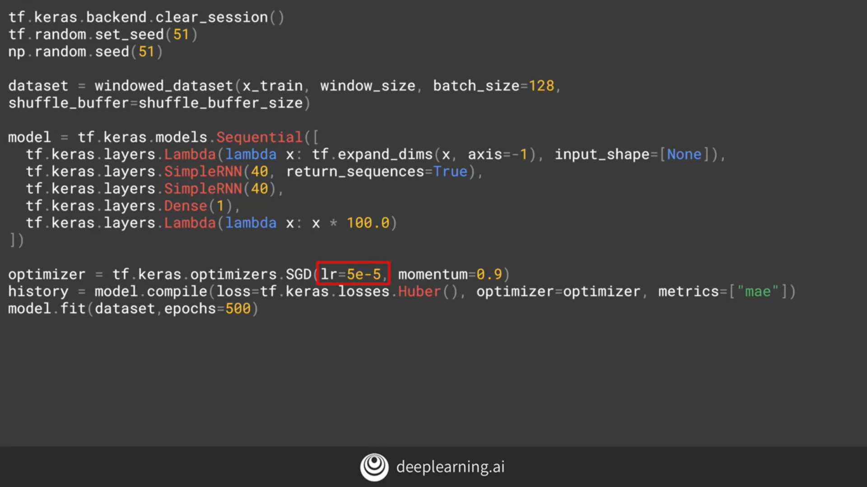

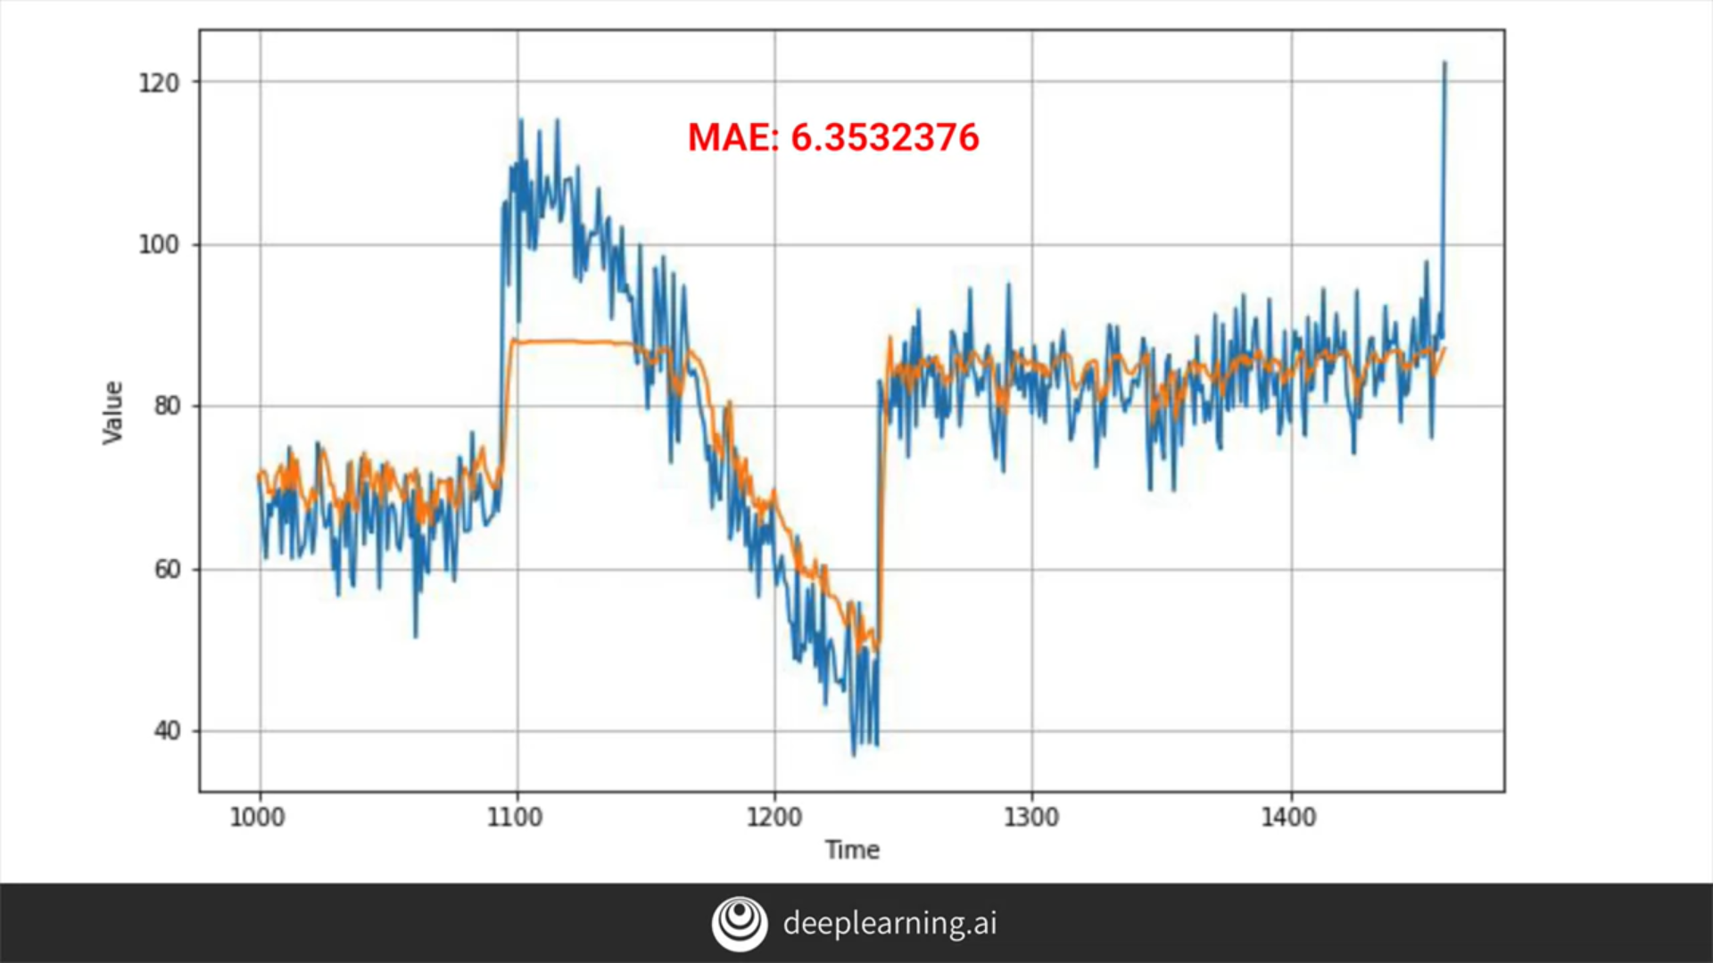

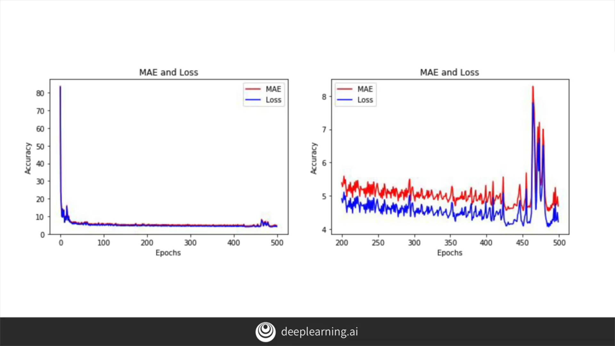

After 400 epochs, the loss increased, so we trained it till 400 epochs and got below result.

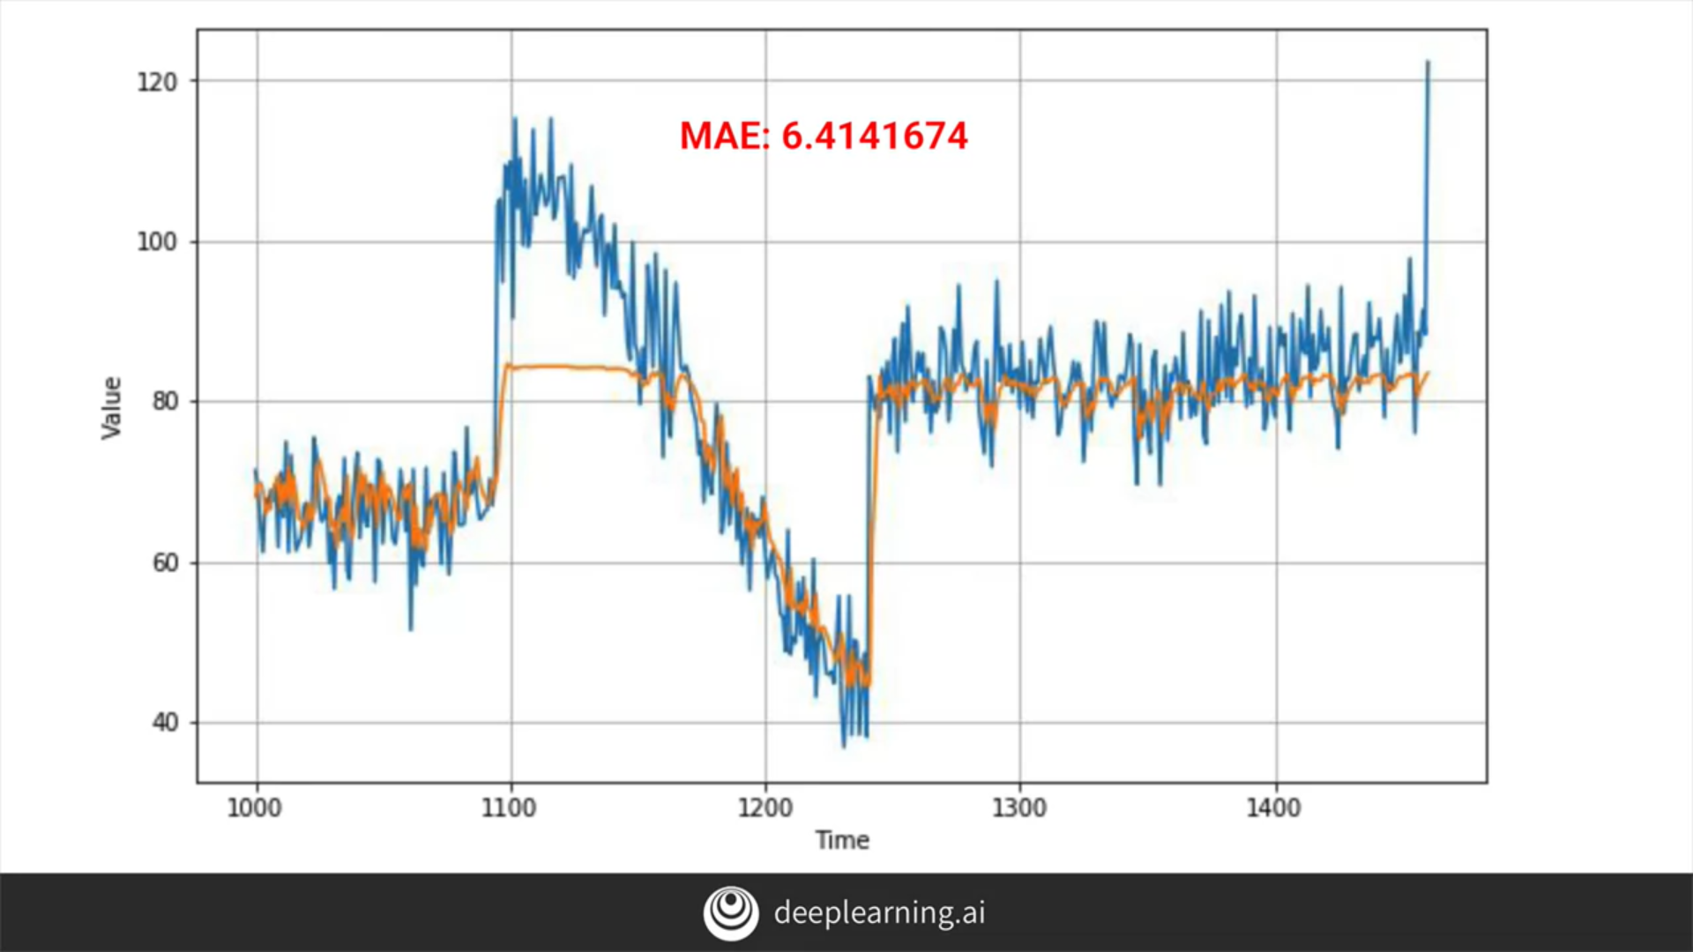

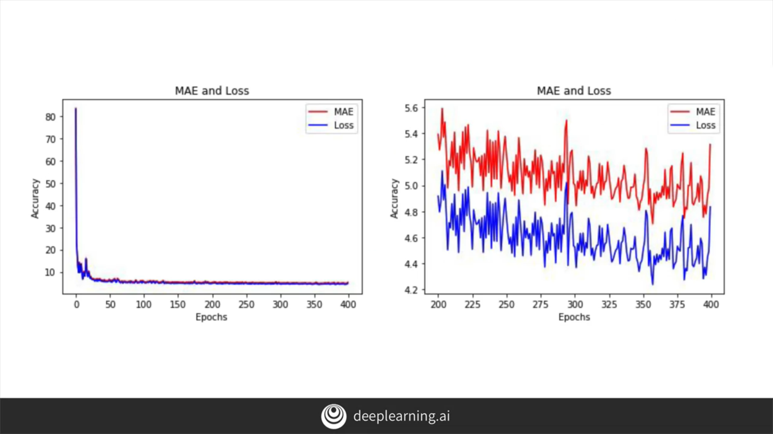

# RNN notebook

# LSTM

RNN looks like this-

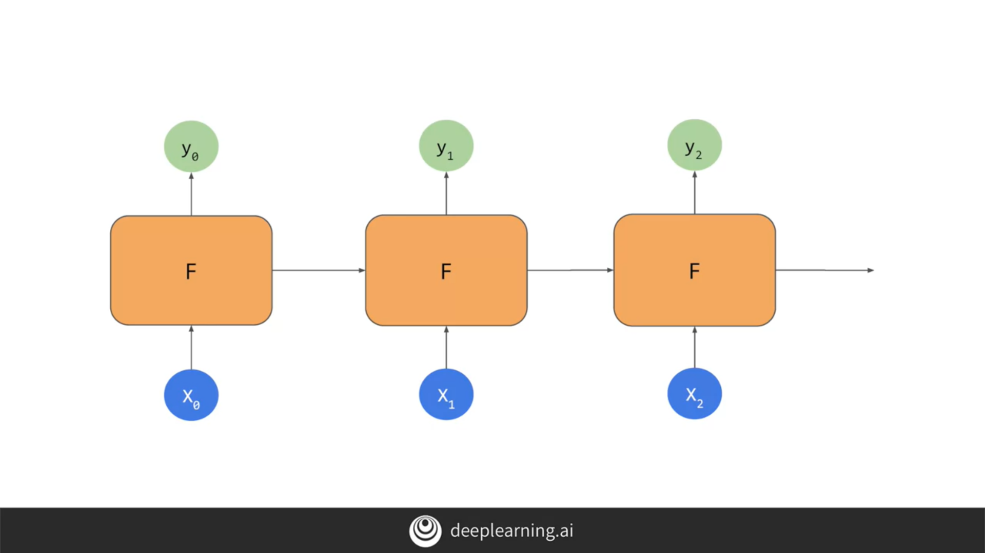

But LSTMs carry cell state-

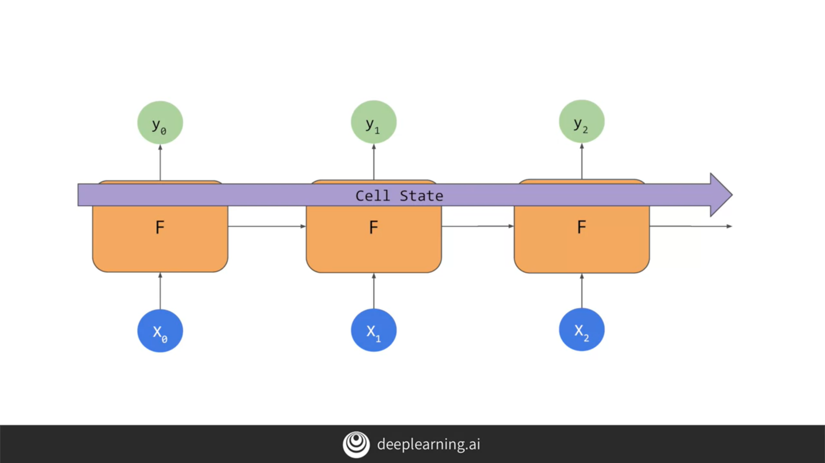

And they can be bidirectional also-

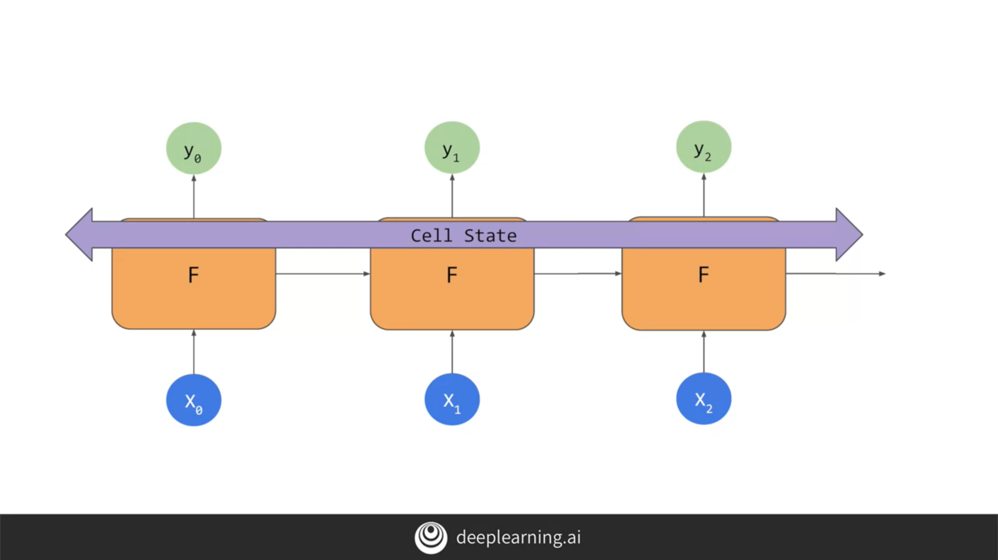

# Coding LSTMs

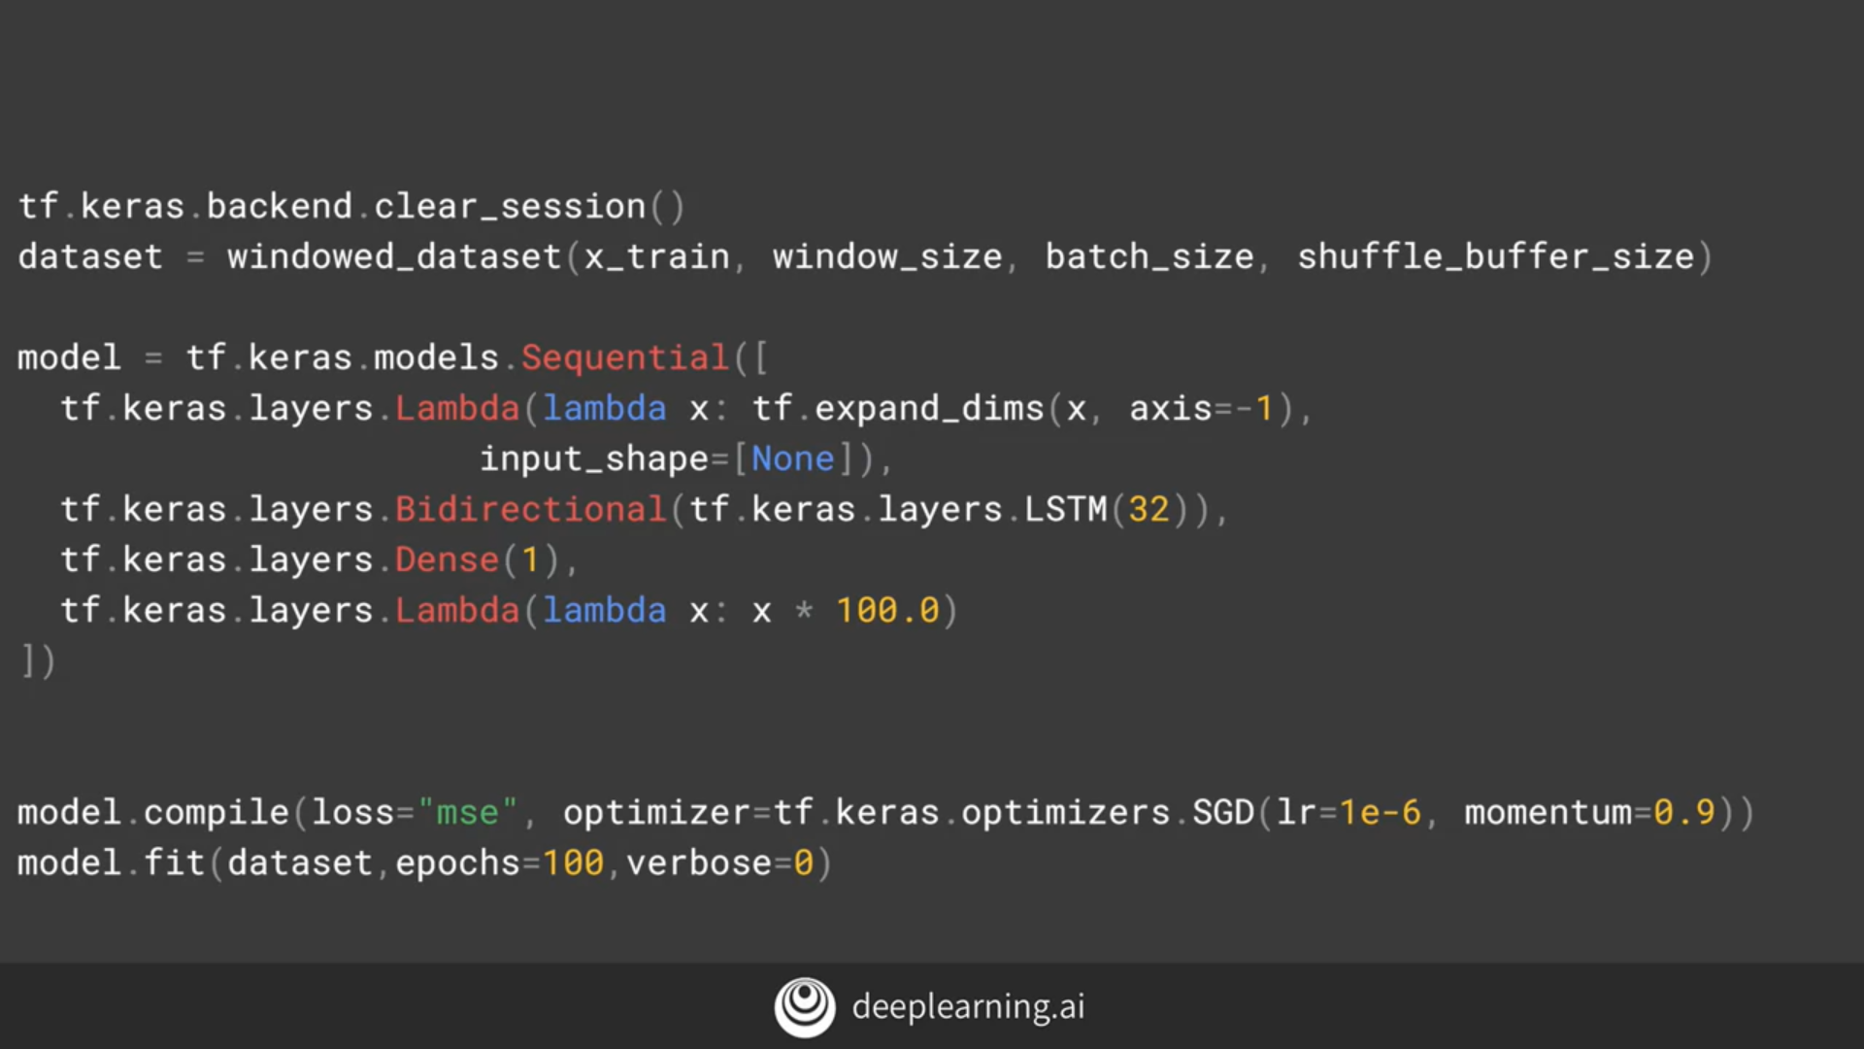

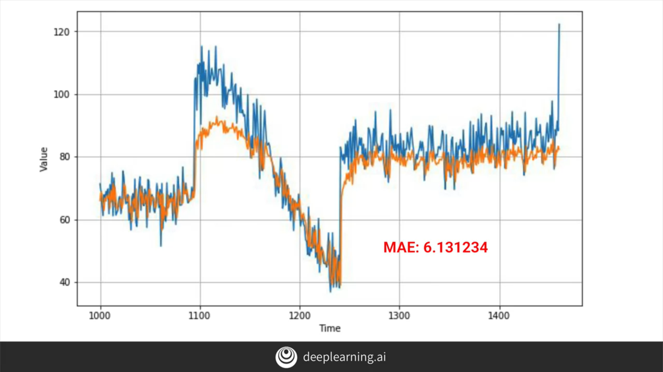

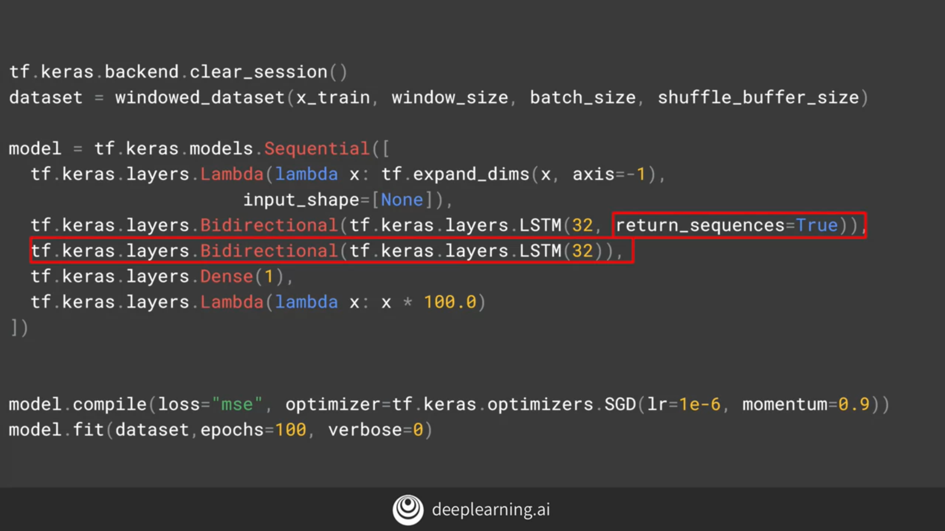

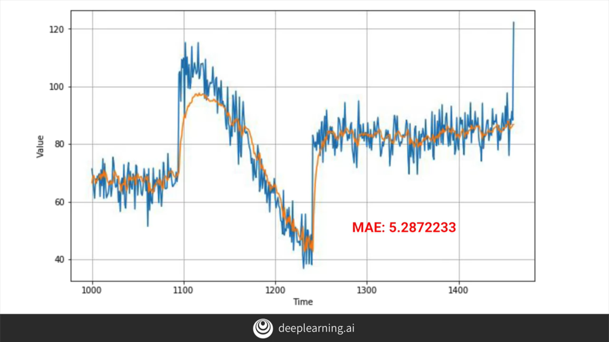

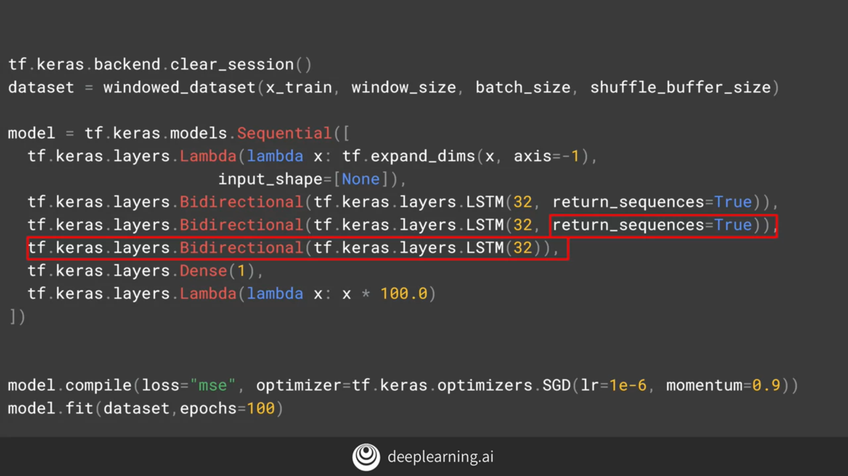

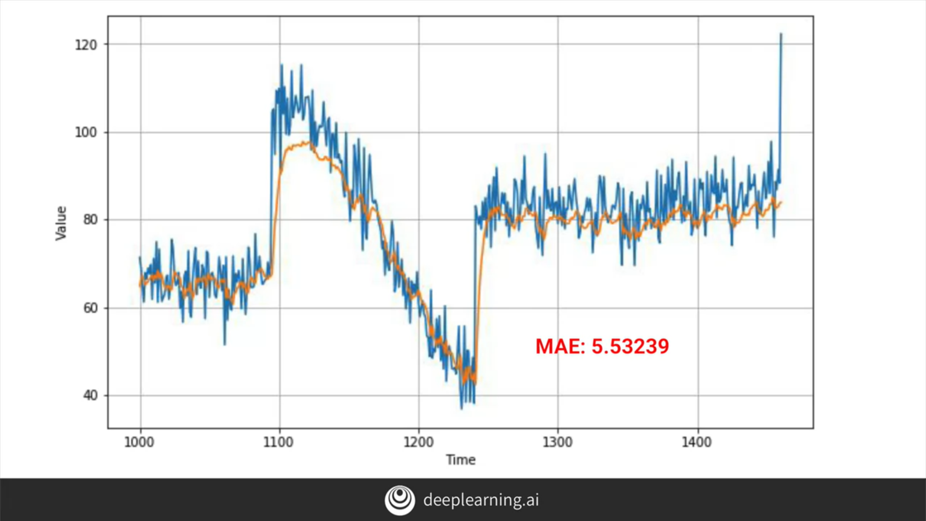

Now that you've built on your DNNs with RNNs and LSTMs, it's time to put it all together using CNNs and some real world data.

Next week you'll do that, exploring prediction of sunspot data from a couple of hundred years worth of measurements!